Shaheer Farooq

Name: Haseem Farooq

Student ID: 467020

Section: ME 15/C

Lab manual 4

LAB TASK 4

1. Write a program in C++ to find the sum of first 10 natural numbers.

INPUT:  
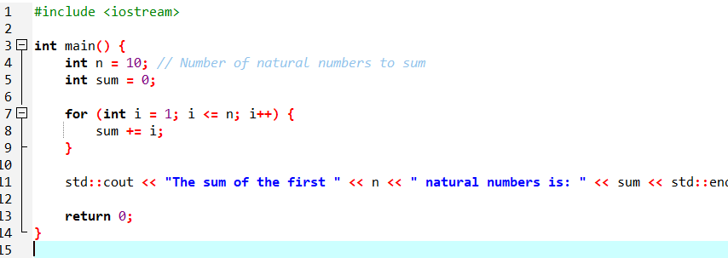  
OUTPUT:  
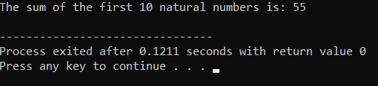

1. Write a C++ program to Print a Table of any Number.

The output should look like this:

INPUT:  
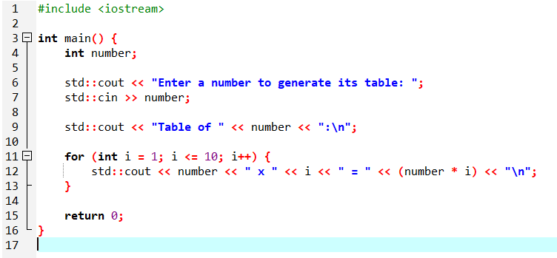OUTPUT: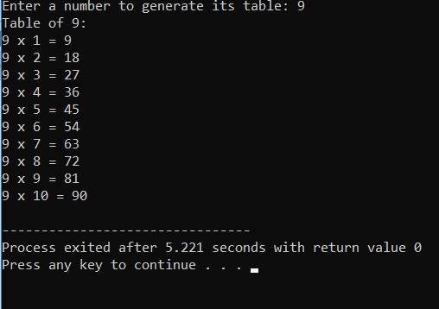

1. Write a Program to Generate Factorial. A Certain Number Factorial of any number is the product of an integer and all the integers below it for example factorial of 4 is: 4! = 4 \* 3 \* 2 \* 1 = 24

INPUT:  
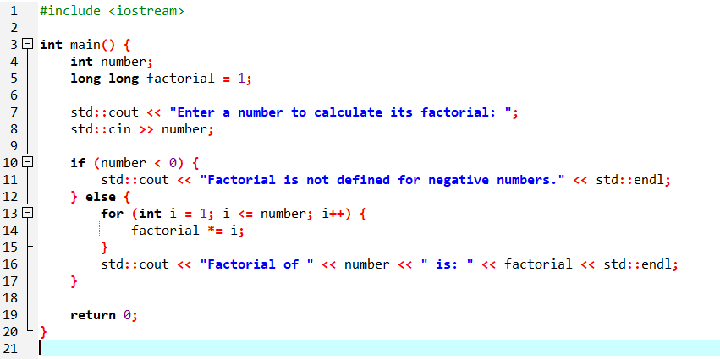

OUTPUT:

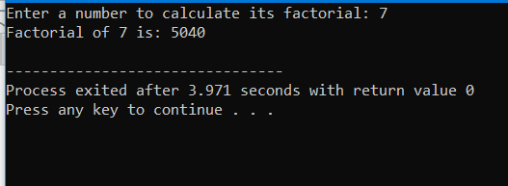

1. Write a C++ program to generate a Fibonacci sequence up to a certain number input by the user.

INPUT:  
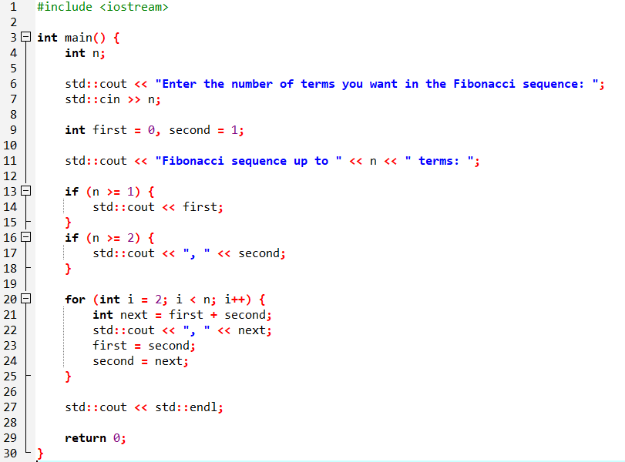  
OUTPUT:  
